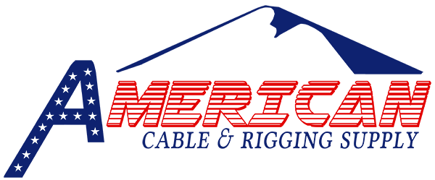

There are many different uses and applications for rigging products and services. Please fill out the form below with what you are looking for and we will do our best to get you a price on the right products you need for your application.

Name: ______________________________________________
Email: ______________________________________________
Phone: ______________________________________________
Company (if applicable):________________________________
Location: ____________________________________________

Please check on the next page what type of products you are interested in getting a quote on and details of application and sizes needed. Some of these products are available on our store, but if you need help finding out which product will best suit your needs we will be happy to help you figure that out.

☐ Slings
☐ Wire Rope
☐ Lifting Devices
☐ Rigging Hardware
☐ Synthetic Rope
☐ Snatch Blocks
☐ Tie Down Equipment
☐ Fall Protection and Safety
☐ Chain Sling Repair
Notes: ____________________________________________________________________________________________________________________________________________________________________________________________________________________________________________________________________________________________________________________________________________________________________________
____________________________________________________________________________________________________________________________________________________________________________________________________________________________________________________________________

